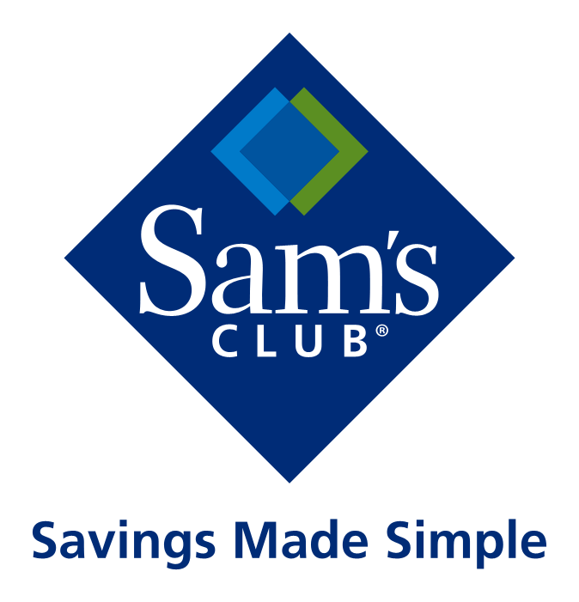

SamsClub.com DSV Overview Guide

"**SAMSCLUB.COM CONFIDENTIAL - Please be advised that this information being provided to you is confidential proprietary information of SamsClub.com USA, LLC and Walmart Stores, Inc. and its related subsidiaries and affiliates ("Walmart"), and is subject to the confidentiality and nondisclosure obligations contained in your legal agreement(s) with Walmart. Except as authorized by Walmart, any use, dissemination, distribution or copying of this information is strictly prohibited.**"

Version 6.0 1 SamsClub.com Confidential Last updated 9/01/15

Introduction

About This Overview Guide

This Overview Guide provides an overview of SamsClub.com Drop Ship Vendor (DSV) partner program

Audience

This Overview Guide is meant for suppliers interested in exploring the benefits and responsibilities of a Drop Ship Vendor (DSV) partnership with SamsClub.com.

How to Use This Guide

This guide is best used as an initial overview of the SamsClub.com DSV program. It is intended to provide a general program overview for potential partners to understand both the benefits as well as the responsibilities associated with entering into a drop ship relationship with SamsClub.com.

In reading through this guide, it’s our hope that many of the initial questions a potential partner might have will be answered. Having said that, we also expect that additional questions, requiring more detail and discussion, will surface and we want to make sure these additional questions are also answered. If while reading through this document additional questions come to mind, please feel free to make a list to discuss these directly with your SamsClub.com Internet Fulfillment (IFM) Manager or your buyer.

Contained near the end is a Frequently Asked Questions (FAQ) section that is helpful in providing additional information from the most common questions we received at the onset of these partnerships.

We sincerely hope this guide serves as a useful tool to learn more about SamsClub.com DSV Program.

SamsClub.com DSV Program Description

SamsClub.com Drop Ship Vendor (DSV) program is an opportunity for external suppliers to partner with SamsClub.com in offering their products to SamsClub.com members. It’s an important relationship for both the potential DSV partner as well as SamsClub.com.

In simple terms, our DSV partners receive orders for their products that we offer to our members on our www.SamsClub.com website. Upon receipt of these orders, the DSV fulfills the order and ships the product directly to SamsClub.com members. The DSV even uses our return address on the shipping label so that the process is completely seamless to the member. SamsClub.com provides the sales channel, marketing and member base and the DSV partner provides the inventory and order fulfillment services.

DSV Partnership Rollout Process

Once a supplier and SamsClub.com jointly decide to pursue a DSV partnership and have negotiated product assortment and pricing for these products, we begin the process of preparing to integrate and launch the new DSV partner’s product(s) on our site. This process involves the coordination and participation of various SamsClub.com teams in order to produce an effective and timely rollout. The various teams involved in a DSV partnership rollout include: Merchandising (Buying), Logistics, Finance/Payables, Returns, and Legal.

A new DSV can help expedite rollout by working with our various team contacts to ensure the appropriate information is communicated in a timely manner. This includes:

- Providing a Contact Directory of relevant contacts for your organization – (i.e. member service, returns, lead fulfillment contact, escalation contacts, etc.);
- Ensuring the appropriate legal representation is available to review and discuss the terms of the SamsClub Stores Supplier Agreement, as well as the SamsClub.com DSV Addendum;
- Providing timely and appropriate content information for merchandising/item setup
- Working with your merchant to ensure your Online Supplier Agreement is current.

Your primary SamsClub.com contacts during your DSV integration will be your buyer and IFM Manager. Your Buyer will be contacting you to discuss the initial information they will need in order to develop a rollout plan for your products on our website. Your support in expediting the requested information will help minimize the time spent getting you up and running as a new DSV partner.

Merchandising Information

The SamsClub.com Merchandising team helps bring your products to our members. They provide the opportunity to communicate the features and specifications of your product and any additional details that make it special. By working with you and documenting information about your offerings, we can do a better job of presenting your products so our members can make satisfying purchase decisions.

Prior to beginning a formal DSV rollout plan, the merchandising team will work with the supplier to obtain a great deal of information regarding item content. This will include all of the necessary information about the product(s) to be offered including SKU(s), colors offered, dimensions and other product information. This information will eventually be entered into our systems and made available to appropriate teams to support our partnership. It will also be used to create content for your product on our website. Ensuring that we have this information at the onset facilitates the partnering process and allows our team to get your products set up in our systems and as a supplier as quickly as possible.

Product Sample
Once your product has been approved and a DSV agreement is being developed, the merchandising team may require a final approved sample from the supplier. (The best person to ask about this directly is your merchant/buyer.) The approved sample is very important and would be used for packaging and product review and product photographs.

Legal Information
Every new DSV partner is required to have a valid SamsClub.com Online Supplier Agreement (OSA) in place. In addition, a SamsClub.com DSV Addendum will be attached to provide the additional necessary detail, required by the drop ship function, and not specified via the SamsClub.com OSA. SamsClub.com requires the completion and signature of both the SamsClub.com OSA and the Legal Addendum prior to initiating a DSV integration project. The Legal Addendum provides more specific details and responsibilities including but not limited to EDI communication, returns handling, carriers, value added services, and service level agreements.

Technical & Operational Information
SamsClub.com will focus on ensuring that a new DSV partner has the operational and technical set-up done to interact with the SamsClub.com order & fulfillment systems. The team works with new DSV partners to gather both technical and operational input from the appropriate teams. Our intent is to identify and plan for potential incompatibilities early on, in order to resolve them timely and effectively, while mapping out the rollout process.

DSV Contact List
Each DSV partner is asked to provide a primary point of contact with contact detail (contact name, telephone numbers, email, etc.) for SamsClub.com in the following areas:
Fulfillment | Member Service | Finance/Payables
Returns | Transportation | Merchandising
Legal | Information Systems | Escalations

A DSV Contact List allows the various teams at SamsClub.com to ask questions to the appropriate resource in a timely manner in order to minimize and resolve problems quickly. If a single person is responsible for more than one area, please note that when providing the contact detail. At launch, the DSV will receive a similar list of contacts based on functional area for the new partner to reference and use in the same way.

Resources

SamsClub.com is committed to supporting the success of our DSV partners. To this end, we’ve developed and provide various tools and resources to facilitate communication and cooperation between our DSV support team and our partners.

DSV Scorecard - In an attempt to collaboratively ensure contractual service levels are maintained, and to identify opportunities for operational improvements, SamsClub.com can provide each DSV partner with a monthly scorecard. These are normally provided within the first two weeks of the month for the previous calendar month.

Escalations - Escalation of issues within SamsClub.com should begin with your Internet Fulfillment Manager (IFM) for issues which occur during the business day.

Scheduled Changes to your Systems or Business processes From time to time, changes may become necessary. In order to facilitate any necessary changes without disruption to normal order flow/fulfillment, please make sure and contact your Fulfillment Account Manager as well as our Site Ops Team in advance of any required changes. A minimum of 10 business days prior notice is required for any change that requires SamsClub.com to make a change (i.e. IP changes, etc.).

Additionally, we require that our DSV partners honor a “freeze period” for the calendar months of November and December, during which they do not make changes to their systems or business processes that impact communication with SamsClub.com.

DSV Integration Process

EDI Data Flow

SamsClub.com
DSV
846 Inventory
824 error
850 Order PO
855 Ack
856 ASN
824 error
810 Invoice
864 error
Additional Considerations

Fulfillment Service Levels
SamsClub.com expects all Suppliers to ship small parcel packages within the established “Standard Lead Time.” If the Supplier receives an order time stamped by SamsClub.com prior to 12:00 noon (local time for the Supplier), the Supplier must return the ship confirm as well as tender to carrier that same business day. If the Supplier receives an order time stamped by SamsClub.com after 12:00 noon (local time for the Supplier), the Supplier must return the ship confirm as well as tender to carrier order shall by the end of the next business day. There are exceptions to this rule, which are defined below:
- Freight/LTL: Items > 150lbs or > 150" in girth shall ship within three (3) business days of being acknowledged by Supplier.
- Preorders: Defined as orders taken prior to their marketed available date.
- Built to Order/Personalized: Defined as items that are specially created and/or personalized with distinct lead times that range by UPC from two (2) days to thirty (30) days.
  - Note: Built to order items are extremely rare. To have built to order items listed on the site, they must first be agreed to and signed off by the Senior Buyer and the Logistics Fulfillment team.
- Factory closings notifications
- *In addition to weekends, we calculate out these holidays as well: New Year’s Day, Memorial Day, Independence Day, Labor Day, Thanksgiving and Christmas. If any of these holidays fall on a weekend, we will calculate out the previous Friday or the following Monday, whichever is closer to the actual holiday. Because items are available for purchase any time, no other days will be considered. It is the responsibility of the supplier to make the necessary adjustments to ship on time, no matter the season.

In exceptional circumstances, DSV must be able to cancel an unshipped order if requested by the SamsClub.com Fulfillment Team.

DSV partner is expected to print packing slips in the format provided by SamsClub.com.

DSV uses this information to print a packing slip. Information printed on a packing slip should only be for the items shipped and not for the total quantity on the order file. Please refer to packing slip mapping guide for detailed packing slip requirements.

Outbound Shipping
DSV Partners are required to utilize our preferred carriers in order to minimize transportation costs. Exceptions are only made if a cost analysis has been completed met with Senior Buyer approval. DSV Partners will continue to use their own Shipper of Record account with outbound carriers, and should utilize a third party account (provided by SamsClub.com) for billing. The exception to this is USPS where third party billing is not supported. For address types only supported by USPS, DSV partner will be asked to pay USPS and then submit costs monthly to SamsClub.com for reimbursement. SamsClub.com considers the individual needs of each DSV and performs a competitive rate analysis to determine which carriers will optimize the efficiency and economics of each partnership. Please be sure to communicate volume estimates, daily pickups, etc., with your local FedEx representatives and escalate any concerns to SamsClub.com Transportation Manager.

SamsClub.com has a specific set of codes which are mapped to corresponding carrier and carrier service method. SamsClub.com will provide customer-selected LOS, Carrier, and Carrier Method in order request. DSV partner should be able to interpret carrier method codes.
DSVs are required to send ASNs (Advanced Shipment Notification) to SamsClub.com as EDI 856s. ASN information will include tracking numbers for each box shipped and include order number in the required format and in the SamsClub.com designated reference field. SamsClub.com will ask DSVs to include item serial numbers in ASNs whenever tracking serial number information is required.

Some items, such as large furniture, can be shipped out in several packages. Multi-box refers to a number of packages required to ship such items. DSV is expected to identify and maintain information for a multi-box item; information may include attributes like number of boxes per unit, details on individual items, shipping info, etc. DSV will report inventory for multi-box items at item level (and not at the package or shipment unit level).
Ship confirmation (ASN) messages for multi-box items are expected at the item level. DSV will report primary tracking number for the top-level SKU. Additionally, any tracking numbers for individual sub-items, if available, should also be provided.

Invoicing Shipping Costs
Typically, a 3rd party account will be set up on your behalf so that shipping costs are billed directly to Sam’s Club shipping account and no further A/P activity takes place with the DSV.

Order Processing and Invoicing
Our standard order processing flow is through EDI. The EDI documents that we have in production for suppliers are the 850, 855, 856, 846 (inventory) and an 824 error message for the 855, 856, and 846.

All suppliers who receive a purchase order must invoice in order for payment to occur. There are two options for this:
- EDI 810
- Web EDI through Retail Link (found under “E-Commerce/EDI”)

Whether a supplier will use the standard EDI flow or use SamsClub.com Eorder will be determined prior to the onboarding process for that supplier.

Metrics
Measured metrics (Logistics and Merchandising)
  - Average fulfillment time
  - Ship rate
  - On time percentage
  - Damage rate
  - Overall return rate

Quality Assurance
Every product sold by SamsClub.com comes with 100% satisfaction guarantee. Members can return products for any reason, and the three most prominent reasons for member returns are: quality, packaging and operational issues. Exceptions to this rule include certain electronics and other special products. We work with our DSV partners to minimize the opportunity for these types of issues to occur and cause our partners, our members and ourselves further issues and costs.

Returns Options
DSVs select to have their returns governed by either a Returns Agreement or an Allowance Agreement.

A Returns Agreement indicates that the DSV will be charged back for the cost returned products. Under this option, a supplier can select from two disposition options: return to supplier or liquidate/dispose. If the supplier elects to have the product returned to their facility, a returns center handling charge will be incurred. This charge is a % of cost, which varies by category (usually 10%). Returns Agreement DSVs that select the disposition code “return to supplier”, are billed monthly for cost of goods associated with their returned product. Returns agreement DSVs that select the disposition code of “liquidate” are billed quarterly and do not incur a returns center handling fee.

An Allowance Agreement indicates that that the DSV will prepay a percentage of sales to offset the cost of their returned product. Returned product for DSVs on an allowance agreement will be liquidated and the supplier will not receive the returned product back. Allowance Agreement DSVs are billed quarterly in conjunction with the reconciliation of returns costs. Should actual returns exceed the total allowance percentage paid the difference will be charged the month following the end of the fiscal quarter being reconciled. Allowance agreement DSVs are not assessed a returns center handling fee.

It is the responsibility of the supplier to give the package to the carrier in such a way that the damage rate is minimized. If the damage rate of any item is deemed excessive we can require standardized testing to be performed at the expense of the supplier.

How are DSV Returns handled?
SamsClub.com members can return a product for any reason. There are two general categories within which most returns are categorized: a) defective/damaged product; and b) member remorse. If a member returns a product due to it being defective or damaged, in most cases the product may be shipped back or returned at any Sam’s Club, (Note: there are a few exceptions to what can be returned via our Returns Centers), a credit for the product is issued and shipping costs are also reimbursed. If a product purchased on our site is returned for a reason that falls within the category of “member remorse”, such as the member decides they don’t want the product after having purchased it, the product may be shipped back to SamsClub.com or returned at any Sam’s Club and a credit will be issued and shipping charges are not reimbursed.

Once the product is received by a Sam’s Club, it may be put back on the shelf and resold at that store. Alternatively, it would be transported to the SamsClub.com Returns Center network before being returned to the DSV partner or disposed of based on the returns agreement of the supplier. Each DSV partner’s Online Supplier Agreement and associated DSV Legal Addendum will detail how their returns will be handled in detail. The entire returns process for an item can usually take 2-4 weeks from the point at which the product is returned (either via a Sam’s Club or directly to our Returns Center)

A supplier decides which returns option it prefers in their DSV Legal Addendum. Separate from the allowance agreement is the disposition code for the returned product. A supplier selecting a Returns Agreement can have returned items shipped back to its facility at its expense or have the returned products liquidated by the SamsClub.com Returns Center network.

Returns Expectations
Our Members do not receive their refunds for returns until the item is received by the supplier and the return is finalized. Timely processing of return orders in SAMSCLUB.COM eORDER is expected so that our member receives their refund as quickly as possible. Returns in the eOrder returns queue should be processed within 24 hours.

Freight/LTL Carrier Claims
Carrier Claims for Freight carriers are handled by our Bentonville, Arkansas office.

Response Time Expectations
To ensure timely responses to our Members’ questions, it is important that we receive a response from our suppliers within 24 business hours.

DSV Frequently Asked Questions (FAQs)

How long will DSV rollout take?
Rollout can take as little as a few days to a few weeks. The EDI onboarding is usually what takes the most time but it is usually the best long term option. Our desire is to get you up and running successfully as a DSV as soon as possible.

What are the benefits of becoming a DSV partner with SamsClub.com?
SamsClub.com is a business unit of Walmart Stores, Inc., the largest retailer in the world. As a DSV partner with us, your products will be accessible to an exponential quantity of consumers with a minimum risk on the part of your business. SamsClub.com is a respected partner to work with and we are committed to the success of our DSV partners.

When and how do I invoice SamsClub.com for products I ship on your behalf?
Invoicing us for product your company ships on our behalf is triggered by your EDI 810 communication with SamsClub.com. Paper invoices are not accepted from DSV partners for the cost of goods.

Miscellaneous Information:

Packing slip

Box Label

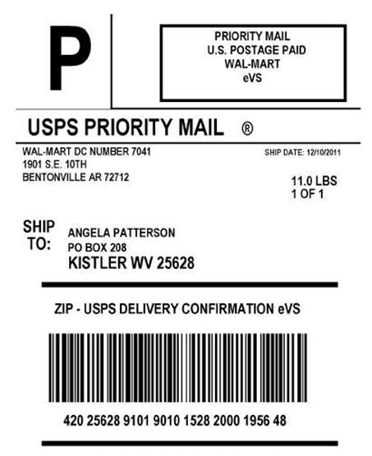

EDI and Retail Link contact
479-273-8888

Insurance Questions
ancruz@wal-mart.com

Packaging information
The packaging guidelines are found here – “SamsClub.com supplier information” in Retail Link

DSV Overview Guide Acknowledgement Form

Once you have completely reviewed this DSV Overview Guide, please sign this acknowledgement form and scansend it back, completed and signed below to:

Attn: New DSV Integrations Team / Philip Schumacher; Karen Gatlin and Frank Hartman.

Philip.schumacher@samsclub.com
Kjgatli@samsclub.com
Frank.hartman@samsclub.com

I have received and reviewed the attached SamsClub.com DSV Program Overview Guide and accept the project expectations.

DSV Partner Name_____________________________________________________
DSV Representative Signature____________________________________________
Who you are working with on the Sam’s Club team_____________________________
Date _______________
Print Name ________________________________________________________
Print Title __________________________________________________________

