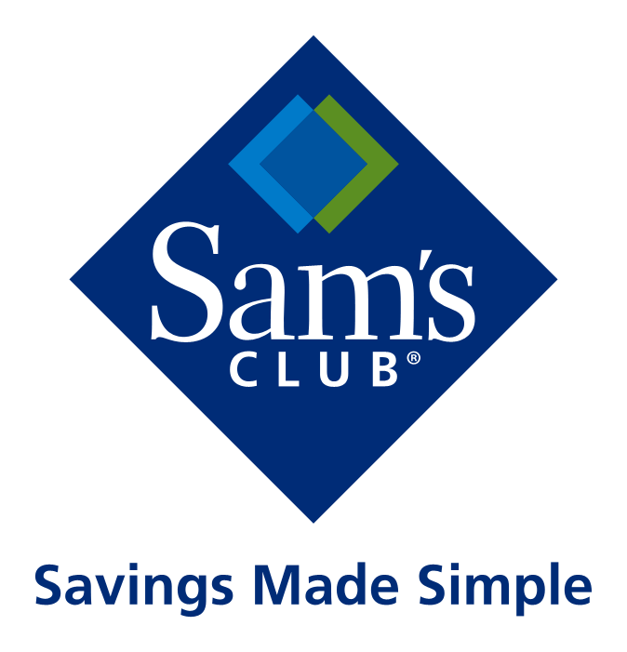

DSV Integration Questionnaire

(Please fill out completely as these will be discussed on the logistics onboarding call)

SUPPLIER NAME: Maxwood Furniture, Inc.

SUPPLIER Number (full 9 digit): 453830-61-0

Sam’s Club.com buyer with whom you are in contact: Matthew Freeman

Supplier contact for Order Resolution: John Arquette

Target Launch Date: 05-01-2016

- Does the supplier have EDI capability? Yes

- What are Supplier’s hours of operation including time zone (PST, MST, CST, EST)? Please provide the hours and ship point addresses here. We need this for the supplier communication section of the Addendum. 9:00 am – 5:00 pm EST

- Does the supplier currently drop ship direct to the consumer for any other company? Yes

- Does the supplier use a third party fulfillment location? Yes

- If “yes” please provide details how order information will be handled. Click here to enter text.

- What product line(s) is the supplier planning to sell on SamsClub.com? Craft: youth bedroom & storage furniture. Jackpot: youth bedroom furniture

- Will the items be small parcel, LTL, or a mixture of both? LTL: loose freight

- Can Supplier meet Standard Lead Time Language? (See below an excerpt from the Addendum to Supplier Agreement). Yes

“Standard Lead Time” is defined to mean the following: (1) if Supplier receives a purchase order time stamped by SamsClub.com prior to 12:00 noon (local time for the Supplier), the order must have confirmation sent to SamsClub.com and be tendered to the carrier within the same business day and (2) if Supplier receives a purchase order time stamped by SamsClub.com after 12:00 noon (local time for the Supplier), the order must have a ship confirmation sent to SamsClub.com and tendered to the carrier by the end of the next business day. (Business days referenced are Monday through Friday, excluding the following holidays: New Years’ Day, Memorial Day, Independence Day, Labor Day, Thanksgiving Day, and Christmas, or in the event a listed holiday falls on a Saturday or Sunday, the day on which the holiday is observed).

The following types of orders or portions thereof, as applicable, however, are not subject to the Standard Lead Time requirements set forth above and have their own respective lead time expectations (“Lead Time Exceptions”):
1 - Items that ship using freight/LTL,
2 - Items requiring sizing/personalization/customization of any kind, or are built to order,
3 – Floral.

The Lead Time Exceptions are as follows:

1 - Freight/LTL. Orders with freight/LTL carrier methods shall ship (and the associated “shipped status” will also be transmitted to SamsClub.com) within three business days of purchase order creation as time stamped by SamsClub.com.
2 - Built to Order/Personalized. Built to Order/Personalized items are defined as items that are specially created and/or personalized as a result of an associated customer order. These products have distinct lead time that range by UPC from two (2) days to thirty (30) days, as mutually agreed to with buyer and are therefore exempt from the Standard Lead Time.
3 – Floral. For floral items that have a delivery date option, Supplier shall maintain an on time ship standard of at least 98% (“On Time Ship Standard”). For items with a delivery date option available at checkout (floral), the on time shipping SLA (service level agreement) expectation is at least 99% and will be measured against the requested delivery date. The On Time Ship Standard shall be calculated on a monthly basis.

Questions for Transportation

- Is Supplier aware that we use 3rd party billing for required carrier FedEx? Yes

- Will the supplier be using our carrier account? If not, has a cost analysis been completed? Yes

- Do any items have delivery conditions (i.e. – White Glove Service, Signature Required, Next Day Service only, etc)? No

- Do any items have shipping restrictions? (Air, state, legal documentation, etc) No

Additional notes. (These are to help with context to the above questions). Please acknowledge each:

Q1
- Under normal circumstances we require vendors to be EDI capable. If you can connect directly or if you utilize a 3PL EDI provider or if you do business with Walmart in any capacity and have an AS2 connection with them, then you are considered EDI capable. (This is not the same as EDI compliant). Acknowledged
- In most instances you will be required to go through the Samsclub.com EDI compliance testing. This will be explained on the call. Acknowledged

Q2
- If you plan not to ship on days other than the listed non-fulfillment days, please follow the communication timeline expectations. Acknowledged

Q7
- We recognize the fulfillment ship time when we receive a successful ASN. Acknowledged
- We expect the ASN to be sent the day the order ships. Acknowledged
- It is the responsibility of the vendor to monitor and address EDI feeds. This means checking for EDI 824 error messages and spot checking within the Samsclub.com eorder portal in Retail Link making sure the ASN feeds are properly working. The EDI 824 error message does not account for every possible scenario. If an issue is identified, it is the responsibility of the vendor to update the ASN through Samsclub.com eorder within Retail Link in the interim until the EDI error is addressed. (The same would be expected with the inventory feeds). Acknowledged

Additional operational information:
- It is mandatory that there be multiple users for Samsclub.com order. The current administrator can request additional users through Retail Link Help Desk. Retail User ID’s cannot be shared. Acknowledged
- If an order cannot be shipped and needs to be cancelled it is the sole responsibility of the vendor to complete this in the Samsclub.com system. This can be done within the Samsclub.com eorder system or through the EDI 855. Acknowledged
- Do not mail paper invoices as these will be rejected. Acknowledged
- Follow the packing slip guide that was sent to you. Many vendors have asked to include the PO number as well. This is okay as long as the necessary information is still included. The order number must be included as this used for the members to reference. Acknowledged

EDI Specific Information:
- When contacting the EDI help desk to begin testing, ask for the Sam’s DSV Testing Documents. Acknowledged
- Once EDI team confirms you have completed the EDI testing and are in production, you can then add inventory. Acknowledged
- Due to potential systemic and payment issues, if you will be going through the EDI testing, do not make adjustments to inventory through the Samsclub.com order portal until testing is complete and you are placed into production. Acknowledged
- After you send your EDI inventory feed, perform these steps:
  - Check for a functional acknowledgement (997).
  - Check for any 824 error message.
  - Validate inventory through Samsclub.com eorder (vendor portal in Retail Link). On the left side of the page click “Adjust All Items”, choose the node number, then hit submit. You can visually spot check if the inventory values you expect have populated. The 846 can take a couple hours to load into Samsclub.com eorder.
  - If the values in eorder are not representative of the values in the inventory feed, contact the EDI help desk right away. If you are using a 3PL EDI provider and want them to represent you, a vendor administrator will need to facilitate the call. Use the EDI Help Desk number - 479-273-8888 or email edi@wal-mart.com. If you are still in production testing, email rollout@wal-mart.com. You can also use the chat option - from home page of Retail Link>> go to Apps>> letter "C">> CHAT With a technician.
Acknowledged

- You must daily check for 824 and 864 error messages. Acknowledged
- If you receive a pending order email from Samsclub.com but find the ASN was already sent at least a day prior, please assume that there is an issue with the ASN. Acknowledged
- In the event that you experience EDI issues, Samsclub.com eorder can be used to manage inventory levels, print out packing slips, and send ASN’s. Acknowledged
- For the 846, be sure the node number is included and formatted correctly as per the instructions in the 846 document. Acknowledged
- The 846 snapshot is to be sent one time per day for dedicated items and four times per day if items are not dedicated. Acknowledged
- Proper invoicing is expected. If EDI, be sure this is part of the testing. Because the 810 (on user ID US00) is a universal EDI document and not specific to Samsclub.com ecommerce, the document is not listed under the SamsClub.com Documents/Direct Shipment Vendors header on the EDI page. It exists under the Basic Documents on the EDI page. If you do not have an AS2 connection, invoices need to be processed through Web EDI in Retail Link. Acknowledged
- If orders are received prior to the completion of EDI testing, you will need to use Samsclub.com eorder to manage these. This is because the format of the 850 (on user ID US00) will replicate the brick and mortar format until the testing is complete. The correct ship to address is not parsed correctly but is contained within the notes, or MTX section of the document. A new 850 (on user ID USSM) cannot be created for these old orders. Acknowledged
- Sender/Receiver ID – use the same in production that was used in testing. Note that you will create a sender and a receiver ID in the testing portal. Your Walmart ID will be 08/925485USSM. (Important Note - invoices will still be sent under the existing ISA 925485US00). Acknowledged
- Although we tend to field and therefore are able to answer some basic EDI questions, we do not have visibility to the EDI feeds or access to Web EDI. If you have an EDI flow question, it is best to contact the EDI help desk first. Acknowledged

Additional Information
- We will begin instituting vendor penalties on late shipments and also cancellations that are due to inventory inaccuracies. Acknowledged
- Communicate via email to the Sam’s Club.com logistics team when you are in production (live with Samsclub.com EDI). Acknowledged
- If contacts ever change it is necessary to inform the logistics and merchant teams.
- The Item Set-up and EDI can be done concurrently. Acknowledged
- Ship how the order comes across via EDI (or as shown in Samsclub.com eorder). If questions arise as to the ship method, contact your merchant team as they are responsible for setting up the ship method of items according to the dimensions provided by the vendor.
- If pricing questions arise, contact your merchant team. Acknowledged
- All items posted onto the site contain an expected delivery date (EDD). It is the responsibility of the vendor to hand the order to the carrier in time to deliver according to the EDD. Acknowledged
- It is the responsibility of the vendor to provide accurate tracking information as this information will be sent to the member via the ship confirmation email. Acknowledged

